

**Hamdard Learning Management System**

By

**Bilal Akhtar**

(ECI-IT-15-104)

**Rizwan Ahmed Khalil**

(ECI-IT-15-097)

**Zunair Kaleem**

(ECI-IT-15-110)

Under the supervision of

**Mam Saadia Mooqaddas**

**2019**

**Faculty of Engineering Sciences and Technology** Hamdard Institute of Engineering and Technology Hamdard University, Main Campus, Karachi,Pakistan.



**Faculty of Engineering Sciences and Technology**

Hamdard Institute of Engineering and Technology Hamdard University, Main Campus, Karachi.

**CERTIFICATE**

This project **“Hamdard Learning Management System”** presented by **Bilal Akhtar, Zunair Kaleem, Rizwan Ahmed Khalil**under the direction of their project advisor’s and approved by the project examination committee, has been presented to and accepted by the Hamdard Institute of Engineering and Technology, in partial fulfillment of the requirements for Bachelor of Computer Science.

____________________

Mam Saadia Mooqaddas

(Project Advisor)

___________________ ___________________

(Examiner 1) (Examiner 1)

___________________ ___________________

Dr. Amjad Khan Dr. Aamer Saleem

(HOD Computer Science) (Director, HIET)

|  |  |
| --- | --- |
|  | **Project in Brief** |
| **Project Title:** | Hamdard Learning Management System |
| **Objective:** | To resolve the ultimate problem of gathering the data from different platforms. |
| **Undertaken By:** | Bilal Akhtar, Rizwan Ahmed Khalil, Zunair Kaleem |
| **Supervised By:** | Maam Saadia Mooqaddas |
| **Date Started:** | October,2018 |
| **Date Completed:** | July,2019 |
| **Tools Used:** | Sublime Text Editor  Internet Browser |
| **System Used:** | 2GB RAM, Internet access of 2mb or above, 3 GB of hard disk space • Screen resolution min 1024 x 768,   |  |  | | --- | --- | |  | **Project in Brief** | | **Project Title:** | [Project Name] | | **Objective:** | [Objective of the project] | | **Undertaken By:** | [Student Name] | | **Supervised By:** | [Supervisor name] [Supervisor Designation] | | **Date Started:** | [Month, Year] e.g. June, 2012 | | **Date Completed:** | [Month, Year] e.g. August, 2012 | | **Tools Used:** | [ State all the tools used for and during the project] e.g.  Microsoft Office Visio 2003 Microsoft SQL Server 2005 Microsoft Visual Studio 2008 Adobe Photo Shop 7.0 DHTML Menu 9.0 Macromedia Flash Player | | **System Used:** | [Specs of the system used] e.g. Pentium IV, Processor 1.5 GHz |   256 MB RAM but 1 Gig preferred • Internet access at 56k or above • 3 GB of hard disk space • Screen resolution min 1024 x 768 |

**ABSTRACT**

An advance development of online learning happens with the utilization of Learning Management Systems (LMS) as a tool for creating, distributing, tracking and managing various types of educational and training material. In this project we have resolved the problem which we have faced in our degree which is, to collect the data from different platforms separately. Which waste out time and cause different problems and lose of data/notes sometime. We have developed a platform where students and teachers can interact in an ethical way to share the useful material which helps them both in several ways, by the usage of this system can resolve issues which is pending from many years.

**ACKNOWLEDGEMENT**

All praises and thanks to Al-Mighty**"ALLAH**”, the most merciful, the most gracious, the source of knowledge and wisdom endowed to mankind, who conferred us with the power of mind and capability to take this project to the exciting ocean of knowledge. All respects are for our most beloved Holy Prophet “**HAZRATMUHAMMAD(Peace Be Upon Him)**”, whose personality will always be source of guidance for humanity.

Acknowledgement is due to **Hamdard Institute of Engineering and Technology** for support of this Project, a highly appreciated achievement for us in the undergraduate level.

We wish to express our appreciation to our **Saadia Mooqaddas** who served as our major advisor. We would like to express our heartiest gratitude for their keen guidance, sincere help and friendly manner which inspires us to do well in the project and makes it a reality.

Many people, especially our classmates and team members itself, have made valuable comment suggestions on this proposal which gave us an inspiration to improve our project. We to all the people for their help directly and indirectly to complete our project.

**TABLE OF CONTENTS**

ABSTRACT............................................................................................................4

ACKNOWLEDGEMENT......................................................................................5

TABLE OF CONTENTS........................................................................................6

LIST OF FIGURES................................................................................................8

ABBREVIATIONS................................................................................................9

1. INTRODUCTION.................................................................................................10

1.1 Motivation……………...................................................................................10

1.2 Problem Statement..........................................................................................10

1.2.1 Current System………………………………….......…………….11

1.2.2 The Future System………………………….……….…………….11

1.3 Aims and Objective……………………………………….……...………….12

1.4 Organization of Thesis……………………………………………………….12

2. BASIC CONCEPT AND EXISTING SYSTEM ………………………………………..14

2.1 Project Analysis………...................................................................................14

2.1.1 Purpose of this Project…………......................................................14

2.1.2 Existing System………....................................................................15

2.1.3Problem in Existing System….........................................................15

2.1.4Proposed System………..................................................................15

2.2 Studies on Suitable Programing Language………………………….……....16

3. METHOD ADN MATERIAL/EXPERIMENTAL SETUP AND PROCEDUR.18

3.1 Methodology...................................................................................................18

3.1.1 Feasibility.........................................................................................18

3.2 Number of modules.........................................................................................19

3.3 System Requirement Specifications…………………………………………20

3.3.1 Hardware Requirements…………………………………………...20

3.3.2 Software Requirements……………………………………………20

3.4 Need for Computerization…………...……………………………………...20

3.5 Functional Features of the Model…....……………………………………...21

3.5.1 Input and Output…………………………………………...……...21

3.6 Process Model Used with Justification………………...……………………21

3.7 User manual Training………………………………………………………..22

4. EXPERIMENTAL RESULTS AND DISCUSSION/SIMULATIONS AND

4.1 Use Case Diagram.......................................................................................24

4.2 ER Diagram……….....................................................................................25

4.3 Data Flow Diagram…….............................................................................26

4.3.1 DFD Symbols…………………………………………………….28

4.3.2 Constructing A DFD……………………………………………..28

4.3.3 Salient Features of DFD’S……………………………………….29

4.3.4 Data Flow………………………………………………..………29

4.4 Sequence Diagrams………………………………………………...……..32

4.5 Class diagram…………………………………………………………..….35

4.6 Screen…………………………………………………………………..….36

5. CONCLUSION AND FUTURE WORK.........................................................42

5.1 Benefits…………………………………………………….….……...…..42

5.2 Limitations………………………………………………………………..42

5.3 Summary of Findings……………………………………...……………..43

5.3.1 Conclusion...................................................................................43

5.3.2 Recommendations Actions..........................................................43

5.4 Future Improvement…………………………………………...…………44

6. REFERENCES................................................................................................45

7. APPENDIX.....................................................................................................46

A. CODING.........................................................................................46

**LIST OF FIGURES**

Figure 4.1 Use Case…………………………………………………………………….….. 24

Figure 4.2 ERD…………………………………………………………………………..….26

Figure4.3 Zero Level DFD ..............................................................................................…...30

Figure4.4 Main System flow……………………………………………………..…31

Figure4.5DFD (Login)……………………………………………………………..31

Figure4.6 Add USER Dataflow………………………………………….....……….32

Figure 4.7 Login Sequence Diagram………………………………………………...32

Figure 4.8 Enroll Users Sequence Diagram………………………………………....33

Figure 4.9 Teacher roles Sequence Diagram…………………………………….......33

Figure 4.10 Student roles Sequence Diagram…………………………………….....34

Figure 4.11 Class Diagram………………………………………………………..…35

Figure 4.12 Admin Login……………………………………………………………36

Figure 4.13 Admin Dashboard………………………………………………………36

Figure 4.14 Add Department……………………………………………………..…37

Figure 4.15 Add class/ Semester………………………………………………….…37

Figure 4.16 Add Teacher…………………………………………………………….38

Figure 4.17 Add Subject…………………………………………………………….38

Figure 4.18 Add Admin…………………………………………………………...…39

Figure 4.19 Add Teacher Department……………………………………………….39

Figure 4.20 Signup as Student…………………………………………………….…40

Figure 4.21 Student Dashboard……………………………………………………...40

Figure 4.22 Signup as Teacher……………………………………………………….41

Figure 4.23 Teacher Dashboard……………………………………………………...41

**ABBREVIATIONS**

|  |  |
| --- | --- |
| PHP | Personal Home Page |
| DB | Database |
| UI | User Interface |
| RAM | Random Access Memory |
| GUI | Graphical User Interface |
| ERD | Entity Relationship Diagram |
| HTML | Hypertext Markup Language |
| CSS | Cascading Style Sheet |

CHAPTER 1

INTRODUCTION

**CHAPTER 1**

**INTRODUCTION**

Hamdard Learning Management System is an online platform where teachers and students can interact in order to improve student achievements. We created this system with the idea of human-centered and particularly by putting all the problems that we have faced in our whole degree. This system helps the students and teachers to upload and download materials which are important for exams and stuff. This platform allows teachers to create a quiz, add assignment sand add resources for students to use both inside and outside of the classroom, Hamdard Learning Management System (HLMS) can help to grade these assignments and deliver quick high-quality feedback and they allow teachers to communicate with students in a number of ways.

This system also has admin portal which has all the administrator roles like to add a department, manage the roles of other admin, manage curriculum, add teachers, add students, add class, add a subject and make an announcement.

Admin can also track the activities of the students as well as teachers that when teachers upload assignments and students submitted that assignments same goes for the quizzes, this feature is only in admin portal which is specifically to keep an eye on the activities of teacher and students.

**1.1 Motivation:**

We have faced a lot of problems in our degree and most of the problems were related to the material, which is way too much important for exams and most of the students don't perform best because they don't have all the materials which are included in exams and this problem is as old as this university so, just to resolve this problem and make a better system from which the juniors can take help and perform better than we did. This is the reason we choose this project and resolve all the highlighted problems that we thought this beloved university of ours is facing from decades. Hamdard University doesn't have such E-Learning Management system before but this system is specifically designed for this university and this will be very helpful for all the students of all the departments.

**1.2 Problem Statement**

The problem we are facing from start, is gathering of data from different sources and interaction with the teachers. We don't have our own platform to share data or to interact with teachers to resolves our problems.

**1.2.1 Current system**

Here is the current system of our University where:

* The lectures download, references for students or for lecturing.
* Students submit assignment to lecturer through personal mails or by hand as a hard copy.
* Student only get help from there lectures and the condition is he/she must be present in class.
* New lectures to a course have to get materials on their own.
* Student are required to physical be in the classroom in order to gain knowledge thereby sacrificing all other responsibilities.
* Students are unable to share resources effectively and hold group discussions that are monitored or supervised by lectures.
* If student has any query about something than he only interact with their lecturer if, teacher is present in university or by contacting to the Class Representor.
* HOD takes assessment report from teacher at the end of the semester.

**1.2.1 Proposed System**

Provides a friendly environment where teachers and students can interact with each other Shares study lectures, assignments, quiz and others study material. Gives appropriate access to authorized users updating information can be done easily and we cannot only work efficient and safe but can also keep a backup so no data is loss.

**1.3 Aims and Objective**

One of the main objectives is to provide a web based application that is more efficient and reliable. Our main aim is to provide a user-friendly platform to users to securely share their Information on a system and retrieve that information when needed.

The main objectives of this project are as follows:

* Centralized database management
* To maintain student education with quality
* Automated performance progress and schedule report
* Online interaction between teachers and students
* Reduce time consumption
* Easy operations for the user of the system

**1.4 Organization of this project:**

Learning Management System represents an innovative shift in the field of learning, providing rapid access to specific knowledge and information. It offers online instruction that can be delivered anytime and anywhere through a wide range of electronic learning solutions such as Web-based courseware, online discussion groups, chat and virtual monitoring. One way to start is to define the goals of the desired learning solution. Definition of the goals of an LMS solution is driven by the following factors:

* **To perform task analysis**

Determine the tasks to be taught, identify subtasks and other elements involved, and identify the knowledge, skills, and attitudes required to complete the tasks efficiently and effectively.

* **To review existing capabilities**

Review existing methods and infrastructure for providing learning needs.

**Common goals and objectives include the following:**

* **To reduce learning costs**

In HLMS there are no delays, and no travel expenses. Such learning enables students to take what they have just learned from their computer screens and apply it to the tasks at hand.

* **To motivate Students**

HLMS is considered an effective way to keep up with new technology, to generate new ideas, and to keep your workforce fresh and inspired.

* **To reduce the cost of time**

This system reduces the cost of time by making everything digitally such as online quiz, assignments and study material.

**CHAPTER 2**

**BASIC CONCEPT/EXISTING SYSTEM**

**BASIC CONCEPT/EXISTING SYSTEM**

For many years, the traditional type of information delivery in the world was centered on the teacher, who spoon-feeds the students which concepts to learn and directs them where to look for additional information on these concepts. During those years, teachers centered their academic activities on teaching their students what to learn, where to look, and how to learn. Much of things have changed nowadays. Access to the Internet is easily available through the availability of Internet-equipped school libraries, home PC Internet subscription, and Internet cafes. Teachers have discovered that students prefer multimedia-supported lectures and web-based activities. Teaching styles have groomed into a mixture of traditional and distance education teaching techniques. Today, learning focuses on faculty-facilitated and student-centered activities. The teacher is now merely a facilitator of knowledge and a guide to the students who have the freedom to explore different avenues of information to supplement their learning.

E-Learning comes from using information communications technology (ICT) to broaden educational opportunity and help students to develop the skills they need to. An emerging body of evidence suggests that eLearning can deliver substantial positive effect.

**2.1. Existing Systems**

Our university does not own such centralize system.

* Every teacher use different online platform for sharing their study content with their students.
* Student only get help from there lectures and the condition is he/she must be present in class.
* Students submit assignment to lecturer through personal mails or by hand.
* New lectures to a course have to get materials by students on their own.
* Student are required to be physical in the classroom in order to gain knowledge thereby sacrificing all other responsibilities.
* Students are unable to share resources effectively and hold group discussions that are monitored or supervised by lectures.
* If student has any query about something than he only interact with their lecturer if, teacher is present in university or by contacting to the Class Representator.
* HOD takes assessment report manually from teachers at the end of the semester.

**2.1.2 Problems in Existing System**

* There is no such centralized platform where study materials are available and remotely accessible
* Lectures are not provided on time to students
* Lack of interaction between teachers and students

**2.2 Project Analysis:**

By analyzing our project, we came up with solution that has supported us technically to build this system, that help us in different ways, if not better then at least to the level with which we can compete in the market.

**2.2.1 Purpose of this Project:**

The main objective of this project is to develop such an effective and efficient web-based “Learning Management System” for Hamdard University Islamabad Campus. This system is design to overcome the drawbacks of the existing system and provide permanent solution to existing problems. By automating the system, we can work efficient.

CHAPTER 3

MEHODOLOGY,EXPERIMENTAL

**CHAPTER3**

**METHODOLOGY, EXPERIMENTAL SETUP & PROCEDURE**

**3.1 Methodology**

The methodology chosen must be appropriate and suitable for the development of the system as it will be step-by-step guide that the developer must follow in order to deliver the system successfully. In this chapter, a methodology has been chosen to apply in the development of Hamdard Learning Management System.

Preliminary investigation examine project feasibility, the likelihood the system will be useful to the organization. The main objective of the feasibility study is to test the Technical, Operational and Economical feasibility for adding new modules and debugging old running system. All system is feasible if they are unlimited resources and infinite time. There are aspects in the feasibility study portion of the preliminary investigation:

**3.1.1Feasibility**

The best LMS solution is defined in this study as one in which all LMS components are considered within the total learning infrastructure of our university, such that maximum student success is ensured from both an institutional and System perspective. Aspects of these components within the frame work of student success were assessed by the following attributes:

• **Cost effectiveness**: -

The total cost figures included in this report represent a current snapshot of the LMS expenditures excluding self-hosting and migration cost, is reported to the Assessment team. The benefits of the LMS is expected to be more than cost such as hosting maintenance and other cost that may be incurred.

• **Support and Training:** -

The system must have a virtual learning community provides students orientates templates and professionals, development resources for faculty by providing online help desk services for students and faculty that includes chat, email, telephone available.

**• Ease of Use:** -

The LMS must have ease of use components and no additional instrument questions were developed the system should have a higher level of instructor and administrator perceived application functionality.

• **Scalability**: -

The LMS must be able to report on the number of active course, users, and average course size and storage capacity on their LMS. It should be able to hold a lot of actives but still be able to use a less storage capacity.

**• Sustainability:** -

The sustainability of an LMS is paramount to the future growth of distance learning in the university. The system-wide capability to support LMS-centric learning technology is challenging in both the short and long terms. Colleges differ on LMS preferences but want continued support from the System Office.

* Learning technology offers an effective and flexible means to facilitate learning.
* Increased enrollments have negatively affected instructors, strained facilities, and encouraged creative interventions to maximize resources

**3.2 Number of Modules**

The system after careful analysis has been identified to be presented with the following modules.

The Modules involved are

1. Administration
2. Users (student/Teacher)
3. File Uploading and Downloading
4. File Sharing
5. Messaging
6. Registration
7. Authentication
8. Notification

**3.3 System Requirement Specifications**

**3.3.1 Hardware & software Requirements:**

* Processor: 1GHz
* RAM: 1GB
* Hard disk: 40 GB
* Peripheral devices

**3.3.2Software Requirements:**

* Operating system: Windows XP
* Developing tool: Sublime3
* Backend: SQL server 2008

**3.3.3Studies on Suitable Programming Languages**

**PHP**

HYPERTEXT PREPROCESSOR(PHP)is a general purpose programming language designed for web development. It was originally created by Rasmus Lerdorf in 1994. PHP code may be executed with a command line interface (CLI), embedded into HTML code, or used in combination with various Web template system, web Content management system, and Web frameworks. PHP code is usually processed by a PHP interpreter implemented as a module in a web server or as a Common Gateway Interface (CGI) executable. The web server combines the results of the interpreted and executed PHP code, which may be any type of data, including images, with the generated web page.

It is integrated with a number of popular databases, including MySQL, PostgreSQL, Oracle, Sybase, Informix, and Microsoft SQL Server PHP is pleasingly zippy in its execution, especially when compiled as an Apache module on the UNIX side. The MySQL server, once started, executes even very complex queries with huge result sets in record-setting time.

**Common uses of PHP**

•PHP performs system functions, i.e. from files on a system it can create, open, read, write and close them.

•PHP can handle forms, i.e. gather data from files, save data to a file, through email you can send data, return data to the user.

•You add, delete and modify elements within your database through PHP.

•Access cookies variables and set cookies.

•Using PHP, you can restrict users to access some pages of your website.

•It can encrypt data.

**Characteristics of PHP**

Five important characteristics make PHP's practical nature

• Possibility

• Security

• Efficiency

• Reliability

• Elasticity

**3.4 Need for Computerization:**

We all know the importance of computerization. The world is moving ahead at lightning speed and everyone is running short of time. One always wants to get the information and perform a task he/she/they desire(s) within a short period of time and too with amount of efficiency and accuracy. The application areas for the computerization have been selected on the basis of following factors:

* Minimizing the manual records kept at different locations. There will be more data integrity.
* Facilitating desired information display, very quickly, by retrieving information from users. Facilitating various statistical information which helps in decision-making.
* To reduce manual efforts in activities that involved repetitive work.
* Updating and deletion of such a huge amount of data will become easier.

**3.5 Functional Features of the Model**

As far as the project is developed the functionality is simple, the objective of the proposal is to strengthen the functioning of Task Status Monitoring and make them effective and better. The proposed software will cover the information needs with respect to each request of the user group viz. accepting the request, providing vulnerability document report and the current status of the task.

**3.5.1 Input and Output**

The major inputs and outputs and major functions of the system are follows:

**Inputs:**

Admin enter his user email and password for login. User enters his email id and password for login.

**Outputs:**

Admin can have his own home page. Users enter their own home page. The user defined tasks can store in the centralized database. Admin will get the login information of a particular user.

**3.6 Process Model Used With Justification**

**Accesscontrol for data which require user authentication**

The following commands specify access control identifiers and they are typically used to authorize and authenticate the user (command codes are shown in parentheses)

**User_name or CMS_Id**

The user identification is that which is required by the server for access to its file system. This command will normally be the first command transmitted by the user after the control connections are made (some servers may require this).

**Password**

This command must be immediately preceded by the user name command. It wordk by the complete user’s identification for access control. Since, the password information is so sensitive so, the data is encrypted.

**3.7 User manual Training:**

**a. Management of learning programs:**

- To add a new program: Login → Manage programs and courses → Add a new program → Save.

- To list programs: Login → Manage programs and courses → View programs.

- To edit a program: Login → Manage programs and courses → View programs → Edit → Save.

- To assign subjects to programs: Login → Manage programs and courses → View programs → Edit the subjects of this program → save.

**b. Management of subjects:**

- To add a new subject: Login → Manage subjects → Add a new subject.

- To edit a subject: Login → Manage subjects → Edit.

- To list subjects: Login → Manage subjects.

- To pending a subject: Login → Manage subjects → pending. g. Management of students:

- To add a new student: Login → Manage students → Add a new student.

- To edit the information of a student: Login → Manage students’ → Edit info.

- To list students: Login → Manage students.

- To edit the marks of a student: Login → Manage students’ → Edit marks.

**c. Management of teachers:**

- To add a new teacher: Login → Manage teachers → Add a new teacher.

- To edit the information of a teacher: Login → Manage teachers → Edit.

- To list teachers: Login → Manage teachers→ Setup Classes

- Approving manually students' subject register: Login → Setup Classes → Choose faculty → Manual distribute.

- To setup class: Login → Setup Classes → Choose student→ Setup class.

**3.8 Use Case Diagram**

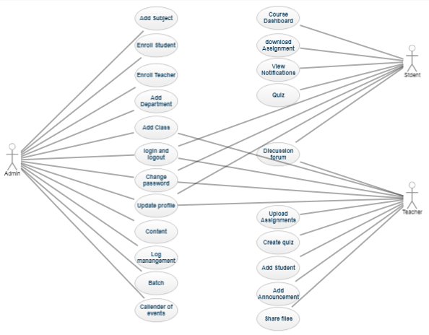Figure 3.1 Use Case

**Name of Use Case:** User Sign-up

**Description:** User need to register himself with a valid username/ID.

**Pre-condition:** The user must have the internet browser along an internet connection.

**Post-condition:** After sign up home page will be displayed.

**Name of Use Case:** Login

**Description:** The user who wants to use our services must login to access the required items.

**Pre-condition:** Each user must have a valid username/ID and password.

**Post-condition:** Homepage will be displayed.

**Name of Use case:** Logout

**Description:** The user can logout in order to keep secure his data or may it not fall in to wrong hands.

**Pre-condition:** The user must be logged in.

**Post-condition**: Start up screen will be displayed.

CHAPTER 4

SYSTEM DESIGN

**EXPERIMENTAL RESULTS AND DISCUSSION**

**SIMULATIONS AND RESULTS**

**4.1 ER Diagrams**

The relation upon the system is structure through a conceptual ER-Diagram, which not only specifics the existential entities but also the standard relations through which the system exists and the cardinalities that are necessary for the system state to continue.

The entity Relationship Diagram (ERD) depicts the relationship between the data objects. The ERD is the notation that is used to conduct the date modeling activity the attributes of each data object noted is the ERD can be described resign a data object descriptions.

The set of primary components that are identified by the ERD are:

* Data object
* Relationships
* Attributes
* Various types of indicators

The primary purpose of the ERD is to represent data objects and their relationships.

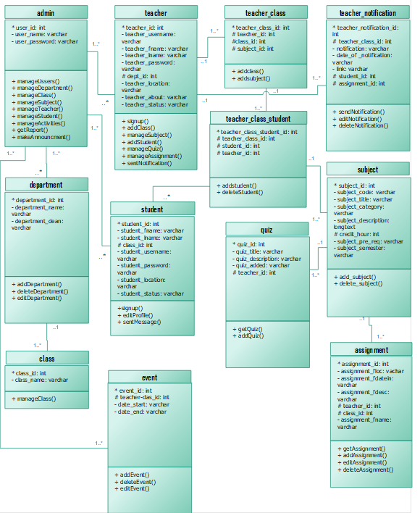

Figure 4.2 ER Diagram

**4.2 Data Flow Diagrams**

A data flow diagram is graphical tool used to describe and analyze movement of data through a system. These are the central tool and the basis from which the other components are developed. The transformation of data from input to output, through processed, may be described logically and independently of physical components associated with the system. These are known as the logical data flow diagrams. The physical data flow diagrams show the actual implements and movement of data between people, departments and workstations. A full description of a system actually consists of a set of data flow diagrams. Using two familiar notations Yourdon, Gane and Sarsen notation develops the data flow diagrams. Each component in a DFD is labeled with a descriptive name. Process is further identified with a number that will be used for identification purpose. The development of DFD’S is done in several levels. Each process in lower level diagrams can be broken down into a more detailed DFD in the next level. The lop-level diagram is often called context diagram. It consists a single process bit, which plays vital role in studying the current system. The process in the context level diagram is exploded into other process at the first level DFD.

The idea behind the explosion of a process into more process is that understanding at one level of detail is exploded into greater detail at the next level. This is done until further explosion is necessary and an adequate amount of detail is described for analyst to understand the process.

Larry Constantine first developed the DFD as a way of expressing system requirements in a graphical from, this lead to the modular design.

A DFD is also known as a “bubble Chart” has the purpose of clarifying system requirements and identifying major transformations that will become programs in system design. So it is the starting point of the design to the lowest level of detail. A DFD consists of a series of bubbles joined by data flows in the system.

**4.2.1 DFD Symbols**

In the DFD, there are four symbols

1. A square defines a source(originator) or destination of system data
2. An arrow identifies data flow. It is the pipeline through which the information flows

1. A circle or a bubble represents a process that transforms incoming data flow into outgoing data flows.
2. An open rectangle is a data store, data at rest or a temporary repository of data

**4.2.2 Constructing A DFD**

Several rules of thumb are used in drawing DFD’S:

1. Process should be named and numbered for an easy reference. Each name should be representative of the process.
2. The direction of flow is from top to bottom and from left to right. Data traditionally flow from source to the destination although they may flow back to the source. One way to indicate this is to draw long flow line back to a source. An alternative way is to repeat the source symbol as a destination. Since it is used more than once in the DFD it is marked with a short diagonal.
3. When a process is exploded into lower level details, they are numbered.
4. The names of data stores and destinations are written in capital letters. Process and dataflow names have the first letter of each work capitalized.

A DFD typically shows the minimum contents of data store. Each data store should contain all the data elements that flow in and out.

Questionnaires should contain all the data elements that flow in and out. Missing interfaces redundancies and like is then accounted for often through interviews.

**4.2.3 Salient Features Of DFD’S**

1. The DFD shows flow of data, not of control loops and decision are controlled considerations do not appear on a DFD.
2. The DFD does not indicate the time factor involved in any process whether the dataflow take place daily, weekly, monthly or yearly.

3. The sequence of events is not brought out on the DFD.

**4.2.4 Data Flow**

1. A Data Flow has only one direction of flow between symbols. It may flow in both directions between a process and a data store to show a read before an update. The latter is usually indicated however by two separate arrows since these happen at different type.
2. A join in DFD means that exactly the same data comes from any of two or more different processes data store or sink to a common location.
3. A data flow cannot go directly back to the same process it leads. There must be at least one other process that handles the data flow produce some other data flow returns the original data into the beginning process.
4. A Data flow to a data store means update (delete or change).
5. A data Flow from a data store means retrieve or use.

A data flow has a noun phrase label more than one data flow noun phrase can appear on a single arrow as long as all of the flows on the same arrow move together as one package.

**4.2.5 Zero LevelDFD:**

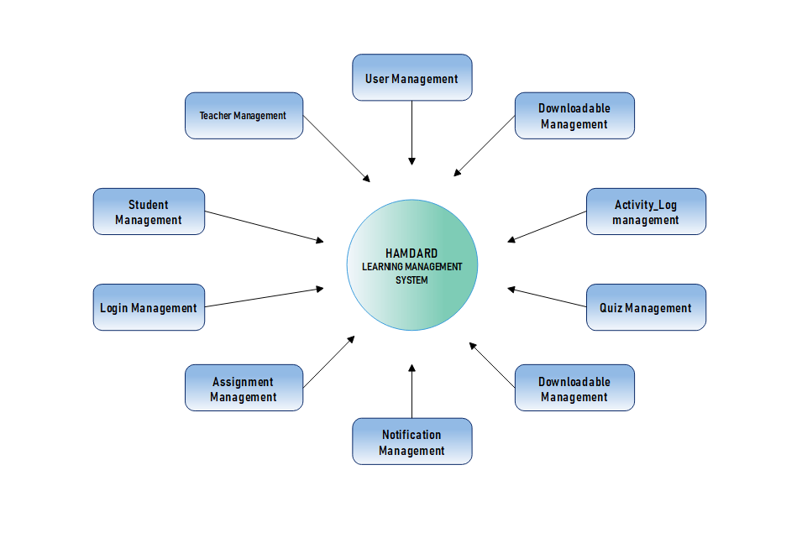

Figure 4.3 DFD

**4.2.6 Main System flow**

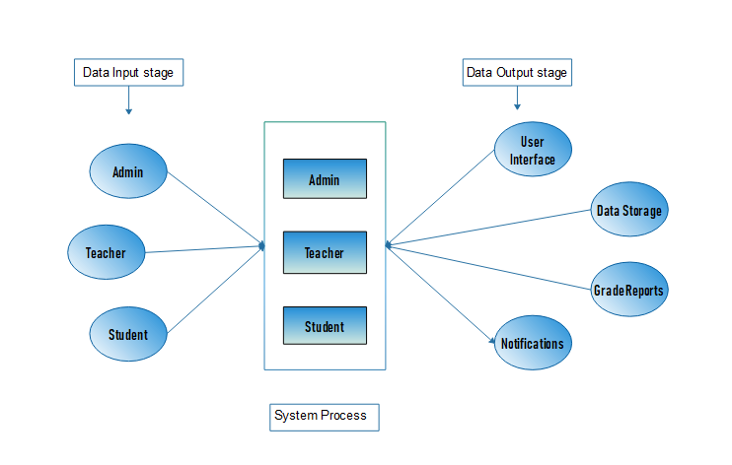

Figure 4.4 Main System flow

**4.2.7 DFD (Login)**

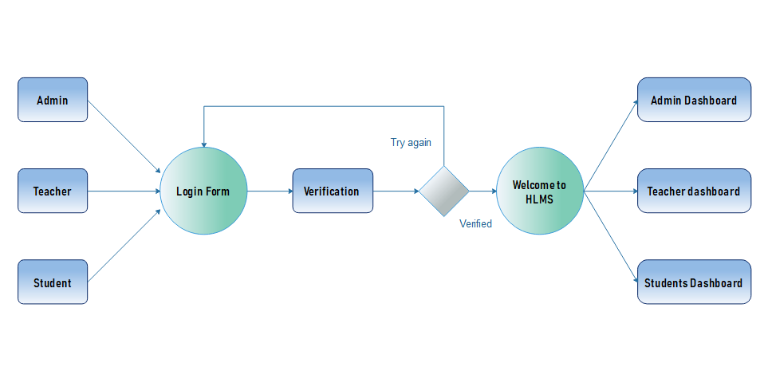

Figure 4.5 DFD Login

**4.2.8 Add Users DFD**

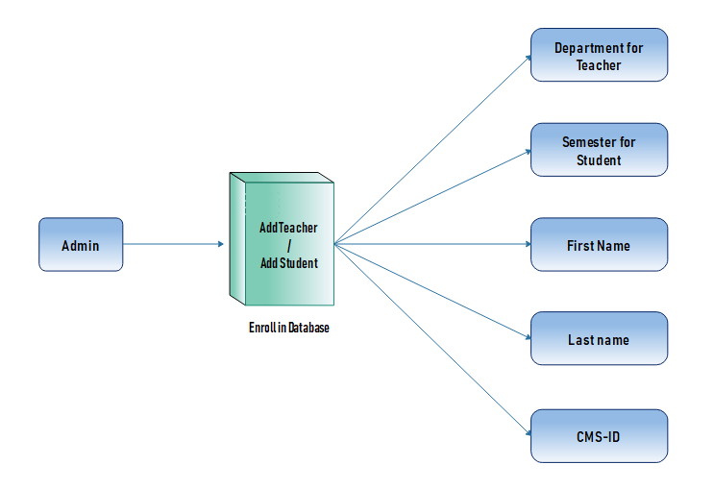

Figure 4.6 Add users DFD

**4.3 Sequence Diagrams**

The interaction diagram that show how operation are performed. Detailed the interaction between the object in the context of a collaboration. Show the interaction by using the arrows, axis to represent the actions.

**4.3.1 Login**

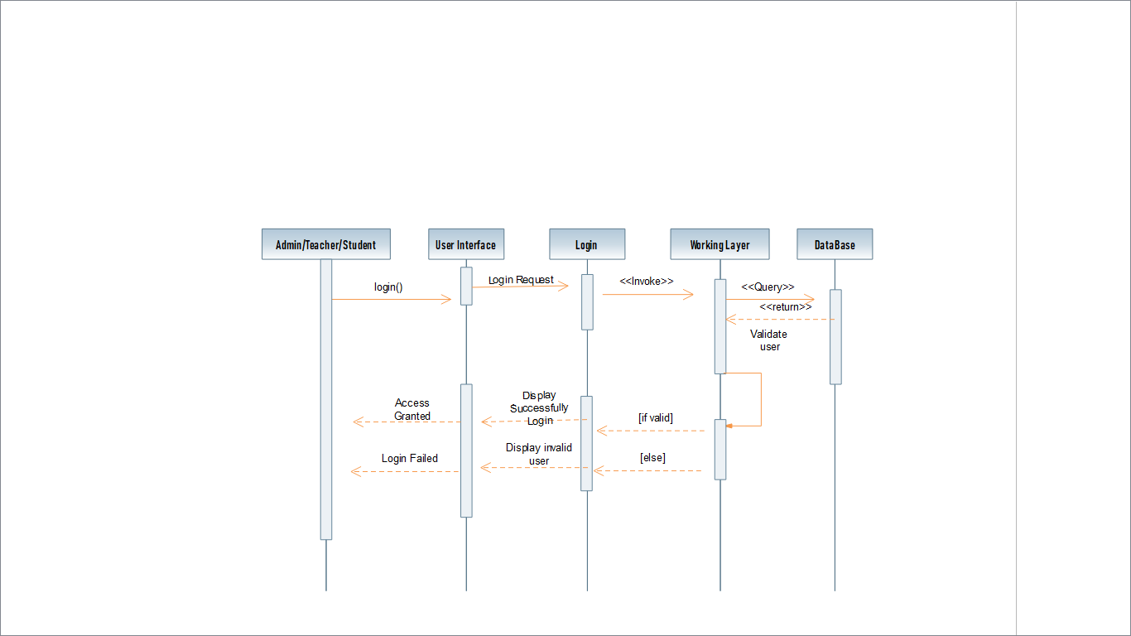

Figure 4.7 Login Sequence Diagram

**4.3.2 Admin role:**

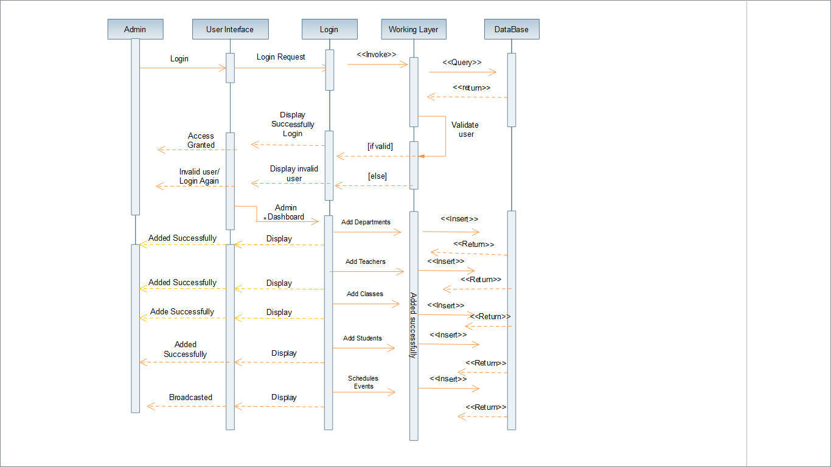

Figure 4.8Enroll Users Sequence Diagram

**4.3.3 Teacher role:**

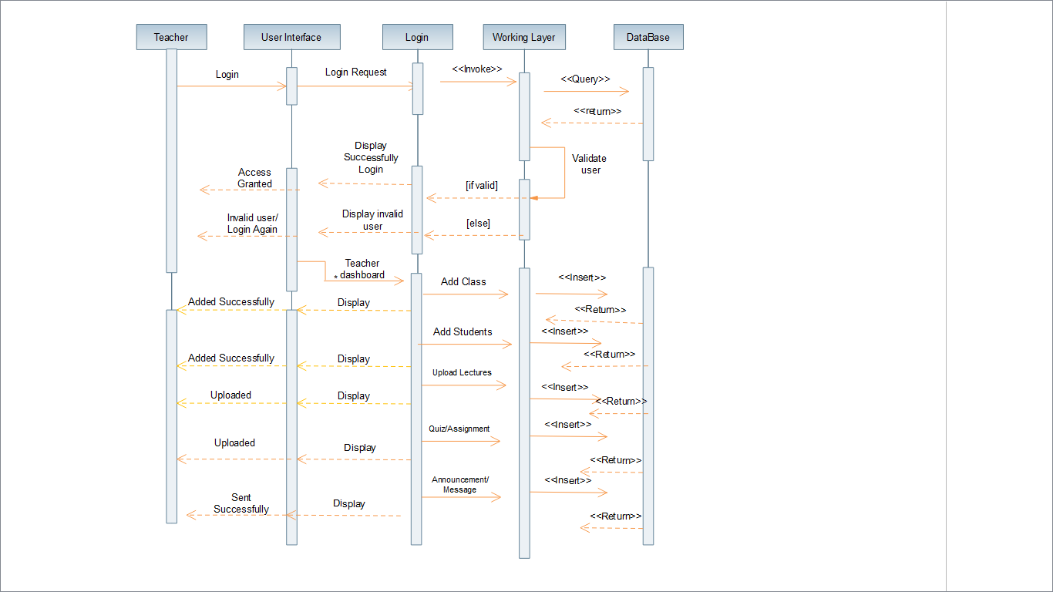

Figure 4.9Teacherroles Sequence Diagram

**4.3.4Student role:**

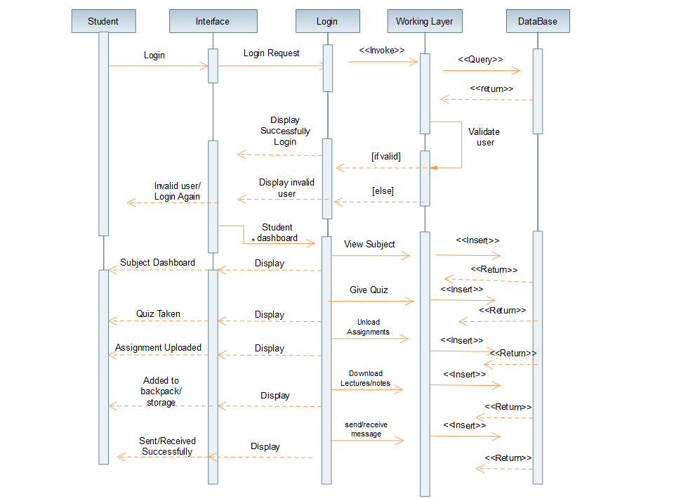

Figure 4.10Student roles Sequence Diagram

**4.4 Class Diagram:**

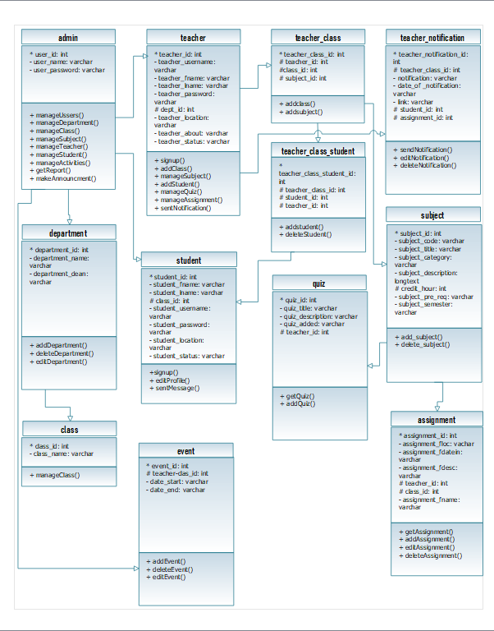

Figure 4.10Class Diagram

**4.5 Screens**

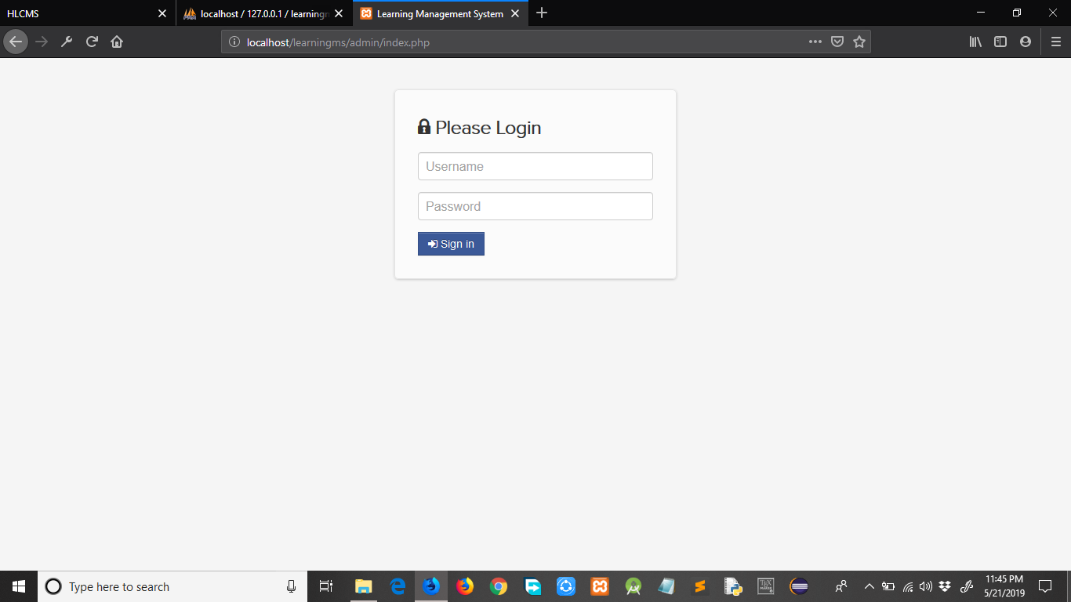

Figure 4.11 Admin Login

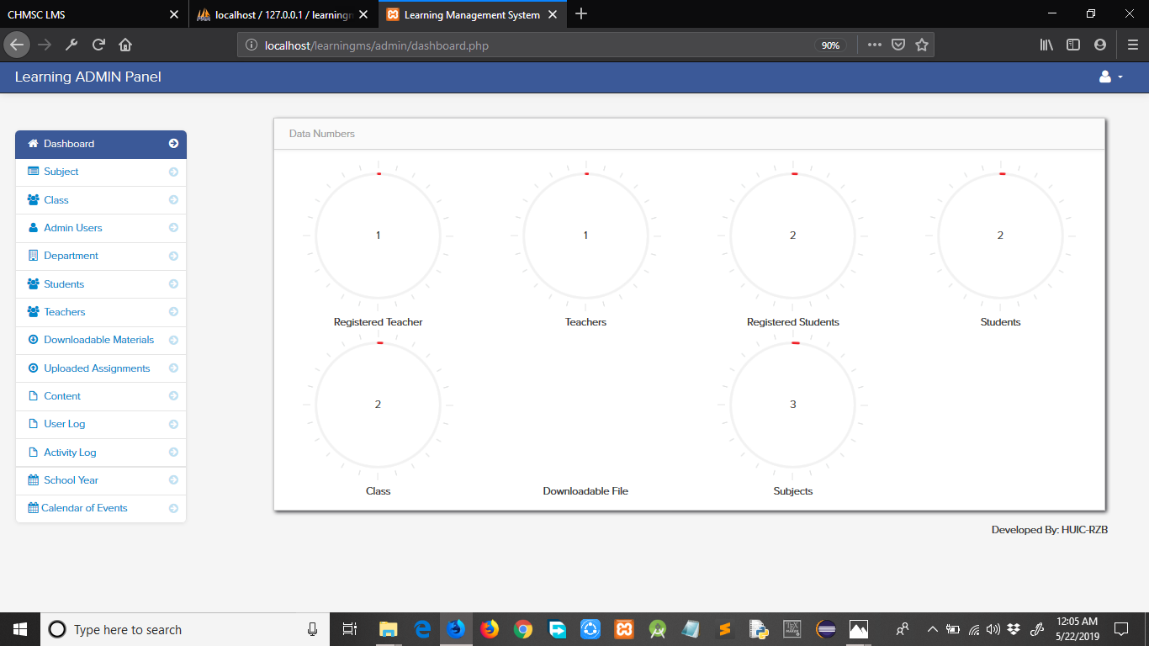

Figure 4.12 Admin Dashboard

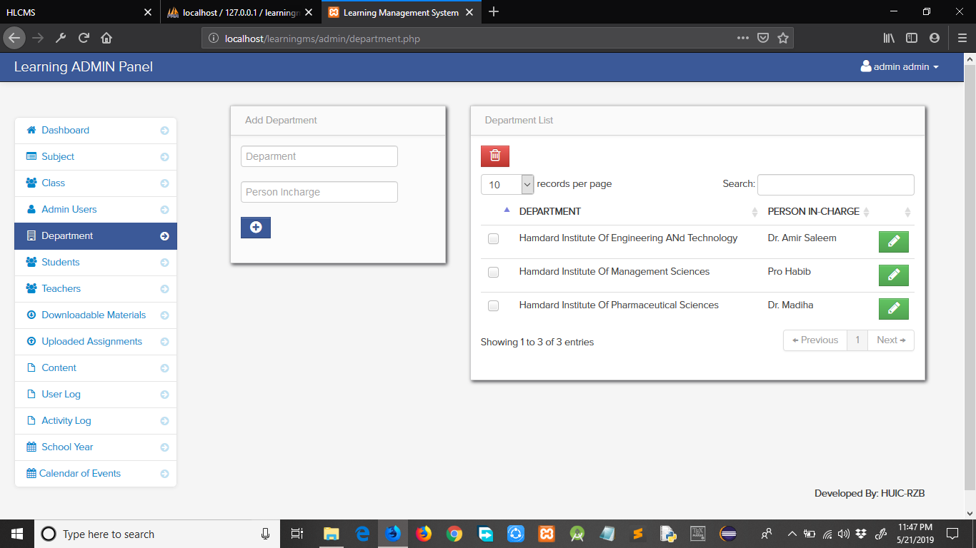

Figure 4.13 Add Department

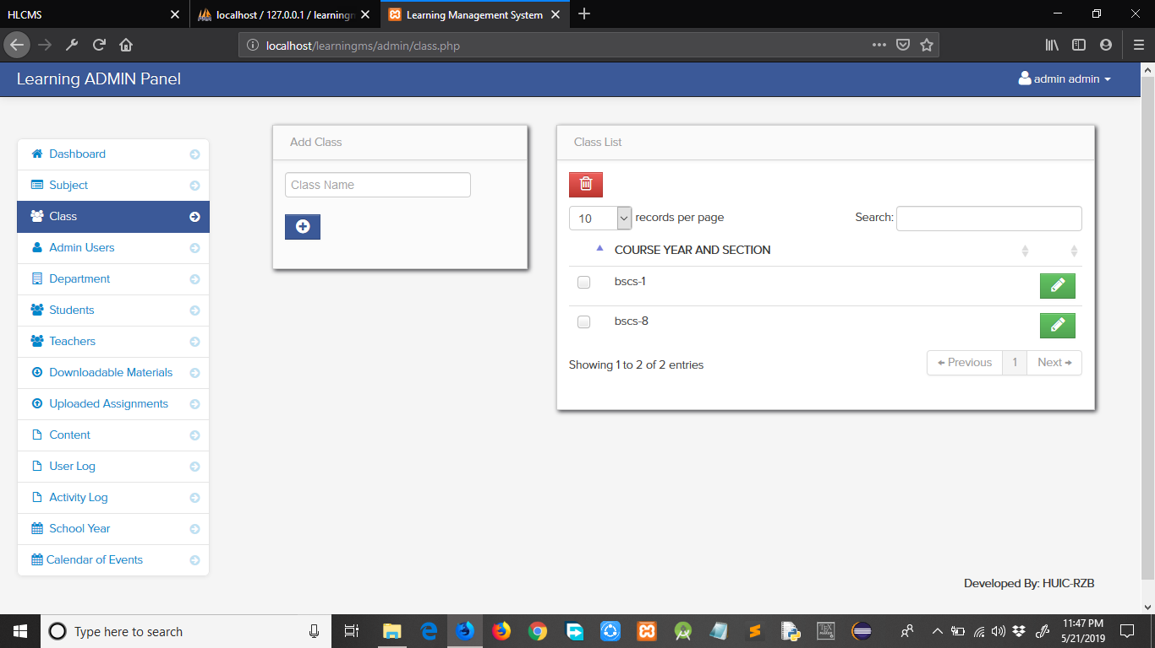

Figure 4.14 Add class/Semester

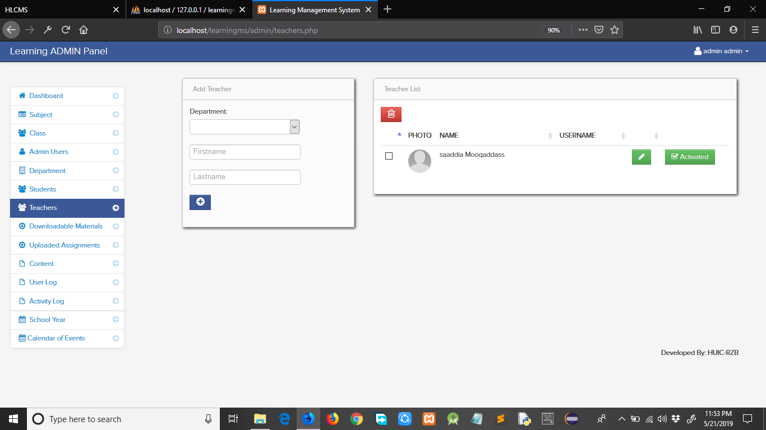

Figure 4.15 Add Teacher

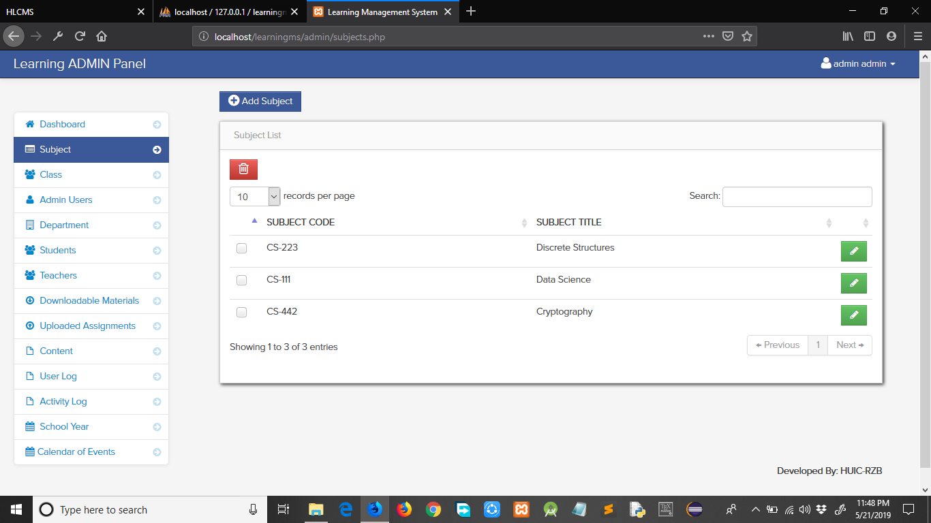

Figure 4.16 Add Subject

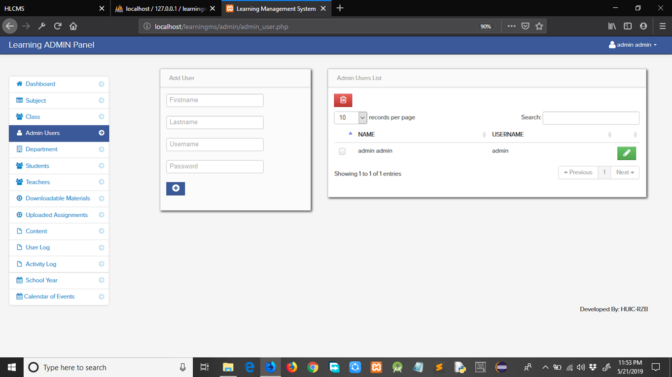

Figure 4.17 Add Admin

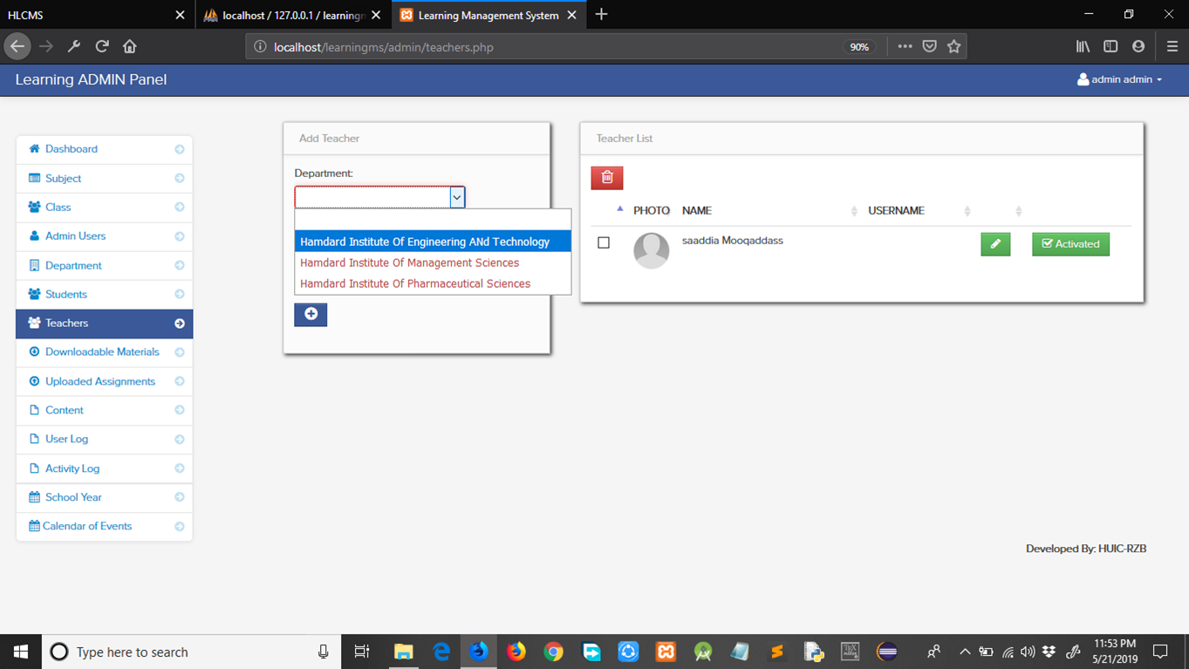

Figure 4.18 Add Teacher Department



Figure 4.19 Signup as Student

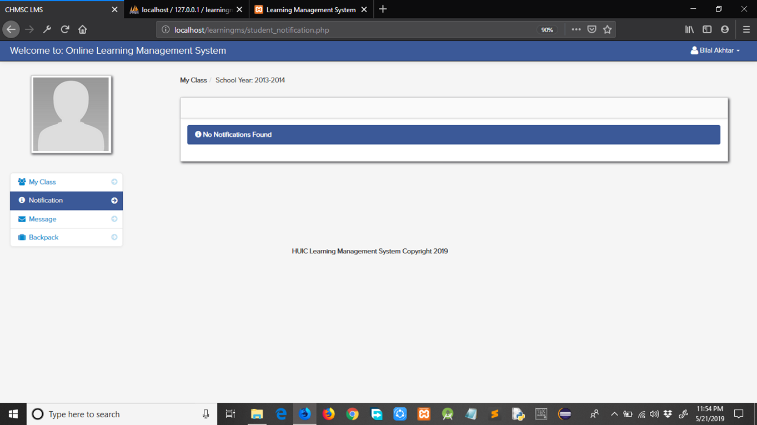

Figure 4.20 Student Dashboard

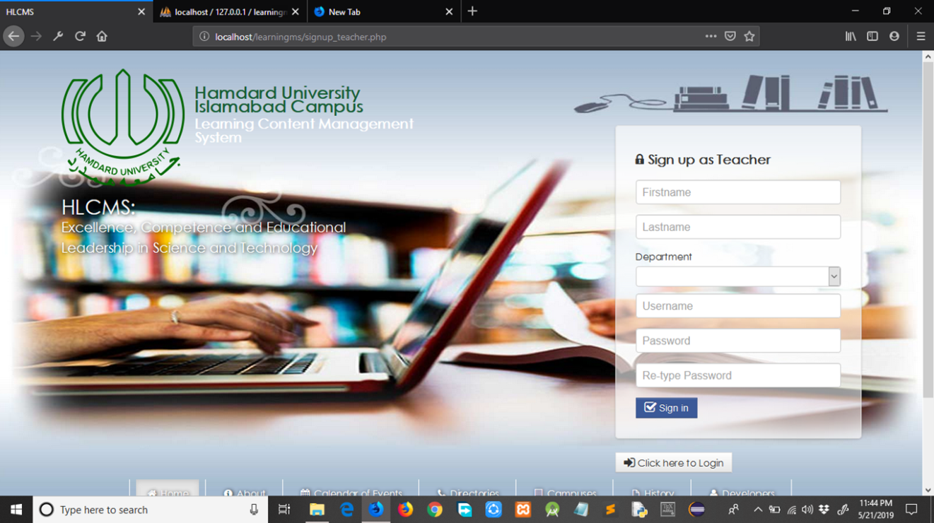

Figure 4.21 Signup as Teacher

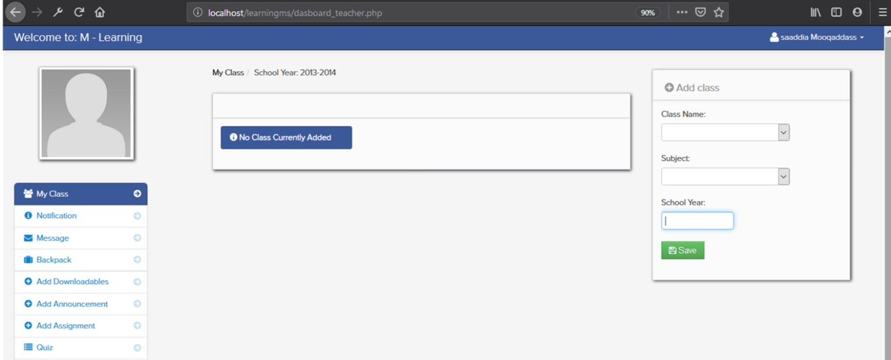

Figure 4.16 Teacher Dashboard

**CHAPTER 7**

**Conclusion**

**CONCLUSION AND FUTURE WORK**

It has been a great pleasure for us to work on this exciting and challenging project. This project proved good for me as it provided practical knowledge of not only programming in PHP and web based application and no some extent Windows Application and SQL Server, but also about all handling procedure related with **“HAMDARD LEARNING MANAGEMENT SYSTEM”.** It also provides knowledge about the latest technology used in developing web enabled application and client server technology that will be great demand in future. This will provide better opportunities and guidance in future in developing projects independently.

**5.1 Benefits**

The project is identified by the merits of the system offered to the user. The merits of this project are as follows: -

It’s a web-enabled project.

* The system-facilitate good interaction and communication facilitates b/w the teachers and administration and students.
* Data storage and retrieval will become faster and easier to maintain because data is stored in a systematic manner and in a single database.
* Easier and faster data transfer through latest technology associated with the computer and communication.

Through these features it will increase the efficiency, accuracy and transparency.

**5.2 Limitations**:

The size of the database increases day-by-day, increasing the load on the database back up and data maintenance activity. Training for simple computer operations is necessary for the users working on the system.

**5.3 Summary of Findings**

After a deep research I found that, there is a lot of information concerning the topic of developing a course repository, but the major problem with the information is that there is a contradiction as to whether the system itself brings in a lot of benefit and there is an argument as to what it should be what are they contains of a course repository and what its limits should be.

**5.3.1 Conclusion**

In conclusion, to this project we find that to develop a fully working system is not only a difficult task but also requires lot knowledge in database design and some programming languages.

Finally, we would like to express ourselves as to how we find this process of developing a system to be very awaking to the mind of a student and to learn how to and teach themselves things. We have built a skill of how to search for things and develop them to our needs. It has indeed been a great experience.

**5.3.2 Recommendation Actions**

By the university implementing this system it will help the institution became more resourceful and avoid an in convince that is caused due some misguided information that passes through to all students and lectures.

The second recommendation action is that final year projects should be done in groups, because with the little knowledge student are, it would help students develop more advanced systems than if they do the alone. It would also easy some of the challenges that students undergo during the project.

**5.4 Future Improvements**

It can be implemented to upload files with a huge amount of size with the support of various file formats.

* This System can be merge with university CMS in future
* We can add parent portal, so the parent can monitors their child activities, grades
* A console for the data center may be made available to allow the personnel to monitor on the sites which were cleared for hosting during a particular period.
* Moreover, it is just a beginning; further the system may be utilized in various other types of operations or similar process/workflow based applications.

From the overall design and implementation of the web application and the mobile application, the system is working up to the mark, and is full filling all the aspects of it use case scenarios. Now a user can access the web application through internet. The user will be able to register him on to our system. Keeping in mind that registered username and password must never be forgotten, since it is unrecoverable. Using the same credentials as for sign up, the user will also be able to login. After that the user may choose to whether he would like to secure sites or secure notes, or may even choose to view, update or delete the saved information. Upon login, users’ data is fetched from the database and user is only limited by the speed of his internet connection

**References**

PHP

<https://en.wikipedia.org/wiki/PHP>

Advantages of PHP

<https://www.eukhost.com/blog/webhosting/advantages-of-php-programming/>

Benefits of PHP

<http://www.eliteinfoworld.com/blog/top-10-benefits-using-php-web-development/>

For SQL

Software Engineering (Roger’s Pressman) <https://www.epa.gov/sites/production/files/documents/paperusage.pdf>

[https://www.cloudways.com](https://www.cloudways.com/)

https://www.codecademy.com/en/tracks/php

**APPENDIX**

**The future system**

The system will hopefully serve as a centralized database of syllabus for the courses offered at the university allowing students and faculties (current, past and prospective), to view them. The system will end up bringing an effective communication among students, lectures, and the administration, by accessing information and other resources anytime, anywhere.

Here are some expected results of the project:

• Lectures to upload assignments and resources for their units.

• Students to download the resources and upload assignments.

• It provides an easy-to-use way to manage course websites that include schedule information, announcements, as well as course discussions.

**Coding:**

**Admin**

**Index.php**

<?php include('header.php'); ?>

<body id="login">

<div class="container">

<form id="login_form" class="form-signin" method="post">

<h3 class="form-signin-heading"><i class="icon-lock"></i> Please Login</h3>

<input type="text" class="input-block-level" id="usernmae" name="username" placeholder="Username" required>

<input type="password" class="input-block-level" id="password" name="password" placeholder="Password" required>

<button name="login" class="btn btn-info" type="submit"><i class="icon-signin icon-"></i> Sign in</button>

</form>

<script>

jQuery(document).ready(function(){

jQuery("#login_form").submit(function(e){

e.preventDefault();

var formData = jQuery(this).serialize();

$.ajax({

type: "POST",

url: "login.php",

data: formData,

success: function(html){

if(html=='true')

{

$.jGrowl("Welcome to HUIC Learning Management System", { header: 'Access Granted' });

var delay = 2000;

setTimeout(function(){ window.location = 'dashboard.php' }, delay);

}

else

{

$.jGrowl("Please Check your username and Password", { header: 'Login Failed' });

}

}

});

return false;

});

});

</script>

</div><!-- /container -->

<?php include('script.php'); ?>

</body>

</html>